**COMP 693 Industry Project**

**Final Report**

**PLANTZZZ UPGRADE: ENHANCING LEARNING**

**IN PLANT IDENTIFICATION**

**(Independent Project)**

Submitted

By

**Name: Wei (Xiangwei) Zhang**

**Student ID: 1139462**

Date:30/05/2024

Lincoln University

**EXECUTIVE SUMMARY**

Use the headings below to give a short summary of the project giving an overview of the problem addressed, goal, methods employed and the outcome in terms of the product/process developed describing its purpose, features and testing as well as its strengths and limitations (**150 words**) **(delete all instructions in the template when you submit your report)**

**Problem Addressed**:

**Goal:**

**Methods:**

**Outcome:**

**TABLE OF CONTENTS**

Provide a table of content for easy access of your content. This provides heading and subheadings and page number where these can be found.

**GLOSSARY/ACRONYMS**

List and define non-typical technical terms and any terms related to the application domain of the project and expand acronyms.

**1. BACKGROUND**

If your project is with a company or involves another organization, provide a brief description of the company/organization and their business. (If you are doing a research project, provide a brief description of the research domain your problem comes under; if you are doing an independent project, describe the hypothetical company or service you are using for this project)

Describe the problem you are solving in your project and why it is a problem to be solved.

Include details of the people involved in the project: Technical, industry, academic, other stakeholders and interested parties as relevant to your project. What was their role in your project?

1.1 Project Overview

The Enhanced Plant Identification Learning Application (Plantzzz App) is an independent study project offered by the School of Landscape Architecture at the Lincoln University. This project falls under the field of Educational Technology (EdTech). The main focus of this project is to enhance the Plantzzz App, a tool specifically designed to help students learn plant names and identification. The goal is to make learning more interactive and engaging through the use of modern technology. Plantzzz Innovations aims to provide students with a user-friendly application that supports their learning journey.

1.2 Problem Statement

The current Plantzzz App (hosted at <https://plantzzz.web.app/>) cannot be updated flexibly and are built on an outdated platform, which negatively affects the learning experience for students. The School of Landscape Architecture hopes that this project can successfully rebuild the plantzzz application and bring students a better learning experience.

The new version of the app will:

* Provide a more user-friendly interface.
* Deliver timely feedback to students.
* Include modern interactive features to enhance learning.
* Align with the educational objectives set by the course instructors.

1.3 People involved in the project

* Faculty Members (Academic stakeholders): The landscape course examiner, Nada and tutor Anna.
* Developer and UI designer

Wei (Xiangwei) Zhang manages the app's development and design, ensuring it meets educational goals and provides a user-friendly interface.

* Beta Tester

Dian Gao, the student of Applied computing, was invited to be the beta tester of the Plantzzz Application.

**2. REQUIREMENTS AND GOALS**

What was the **overall goal** of your project, and what were the **requirements** that must be met for it to be a success.

Include in this section, how you will know if the requirements / goals have been met.

2.1 Overall Goal

The overall goal of this project is to design and develop a plant recognition learning application. The app aims to use a more dynamic and user-friendly design to enable students to more effectively memorize and identify plant names.

2.2 Specific Objectives

* Design a Scalable Database
* Create a User-Friendly Platform
* Improve student and teacher dashboards and other functional features

2.3 Success Criteria

The success of the project will be measured by the following criteria:

* Database Implementation: A database that efficiently manages plant information.

How to evaluate: The database can store all plants’ name information provided by the Landscape tutors and can be effectively used in web App.

* User-Friendly Interface: A modern UI design that allows users to navigate the app easily and interact with its features smoothly.

How to evaluate: Evaluation on the usability obtained from the beta tester. If the evaluation is that it is easy to operate, the design of this part meets the requirements.

* Functional Features: The app can support students in effectively identifying plant name knowledge across all four semesters. All designed features, such as quizzes and dashboards, should work well, providing an engaging learning experience without issues.

**2.1 Literature Review**

If you are doing a research project, provide a review of literature most relevant to your project. This review must summarise the current state of research on the topic in a way that it shows the relevance of your chosen problem and why it needs to be solved.

In the field of educational technology, gamification has become a key strategy to improve student engagement and learning outcomes. Apps like Kahoot! and Quizizz exemplify this approach by incorporating game-like elements into the educational process.

Kahoot!, which originated from the lecture-test research program at the Norwegian University of Science and Technology, revolutionized the classroom environment by using a gamified format (Wang & Tahir, 2020). The platform is designed to foster student engagement and motivation through its interactive setup, utilizing features such as real-time feedback, competitive games, and more. The effect of increasing student engagement and perceived learning outcomes has been well documented through extensive research (Wang & Tahir, 2020).Likewise, Quizizz provides a gamified learning experience that enhances classroom activities by making them more interactive and reducing distractions. It stands out for its rich features, including a game-like environment with levels, leaderboards, music, themes and a user-friendly interface (Meng et al., 2019).

Plantzzz was developed to incorporate similar gamification elements into the field of plant identification education.

**3. METHOD**

**3.1 Overview**

Describe how you structured your approach to the project, including any project management approach used, any specific techniques, tools and/or technologies.

3.1 Overview

The project utilized React.js, Python, MySQL, Flask, GitHub for version control, and Wireframes for UI design. An Agile methodology was followed with weekly sprints to keep track of the progress.

Objective 1: Database Creation: **MySQL Database**

* Reason for Selection: MySQL was chosen for its stability and ease of use.
* Steps Involved:

- Creating the database to store plant data.

- Use Python pandas to read Excel files and generate SQL insert statements.

- Write SQL query to search Quizes and plants information from database

- Update database when quizzes are modified

Objective 2: Frontend Development: **React.js**

* Reason for Selection: React.js was chosen due to its ability to handle high interactivity and dynamic content.
* Steps Involved:

-Developing UI components.

-Implementing data fetching and rendering.

-Enhancing the UI with CSS and Canvas for better visual appeal.

Objective 3: Backend Development

Technology Used: Python and Flask

Reason for Selection: Python is known for its simplicity and extensive library support. Flask is lightweight and suitable for developing RESTful APIs.

Tasks:

Developing APIs to facilitate communication between the frontend and backend.

Using Flask Blueprints for modular development.

Implementing CORS to allow cross-origin requests.

Objective 4: Version Control

Tool Used: GitHub

Reason for Selection: GitHub provides robust version control and facilitates collaboration.

Tasks:

Regularly committing code to maintain version history.

Using branches for feature development to ensure stable main codebase.

Pull requests and code reviews to maintain code quality.

Objective 5: UI Design

Tool Used: Wireframes

Reason for Selection: Wireframes help in visualizing the layout and structure of the user interface before actual development.

Tasks:

Designing wireframes to plan the UI layout.

Using wireframes to guide the development of frontend components.

Objective 6: Integration and Testing

Tools Used: GitHub, Agile tools

Reason for Selection: GitHub ensures effective version control and collaboration. Agile tools support iterative development and regular feedback.

Tasks:

Regular integration and testing of components.

Daily self-reviews and weekly sprints to track progress and make necessary adjustments.

4.2 Project Team

The project team consisted of myself. I was responsible for all aspects of the project, including development, integration, and testing. Regular self-reviews and task management ensured that the project remained on track.

4.3 Skills and Resources

This project provided an opportunity to develop a range of hard and soft skills.

Hard Skills

Frontend Development: Mastery of React.js, CSS, and Canvas.

Backend Development: Implementation of Flask APIs and use of Python libraries.

Database Management: Utilizing MySQL for data handling.

Version Control: Proficiency in using GitHub for version control and collaboration.

UI Design: Experience in creating and using wireframes for UI planning.

General Skills

Problem Solving: Enhanced ability to identify and resolve issues.

Organization and Self-Management: Setting and evaluating weekly goals.

Flexibility: Adapting code and project scope based on feedback.

Communication: Clear and assertive communication during weekly meetings.

**3.1 Design**

Diagram and describe the architecture of your project. How are the components designed and how do they interact with each other. If your project is a software project this should show the various software components, if it is a human focused project it should show the different aspects of the project that needed to be brought together and in which stages. If it is a research project, it should provide the specifics (methods and processes) of each aspect of your solution and how they all work together to address your problem.

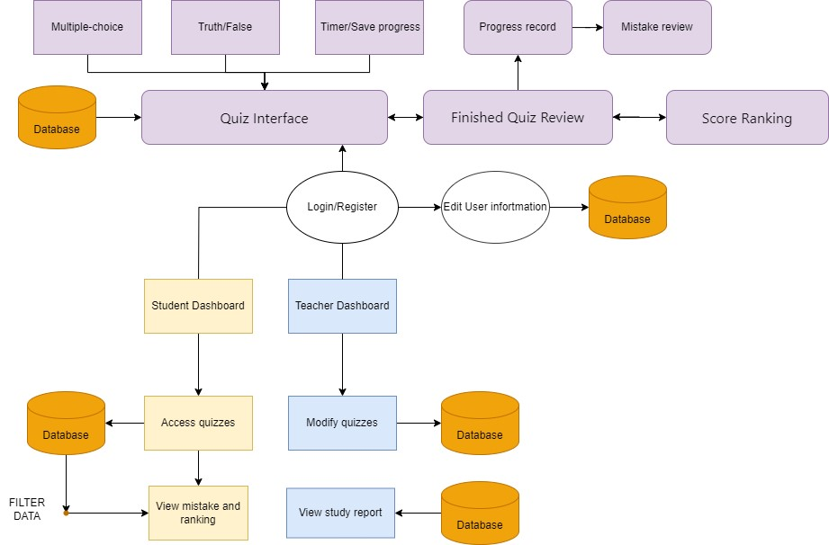

**Software Components:**

* **Student Dashboard**: Ability to access quizzes by clicking on Quiz pictures, modify the profile, and view progress and scores for completed quizzes.
* **Teacher Dashboard:** Can manage quizzes and manage classes (including viewing student progress and rankings).
* **Quiz Interface:** Provides students with an interactive interface for taking tests. It may include multiple-choice questions, true-false questions, etc., and is equipped with music and timers, badges, etc. to increase the gameplay.
* **Quiz Management:** This component allows teachers to create, modify or delete quizzes.
* **Progress Management:** Class progress and rankings can be viewed.
* **Database:** Stores user information, quiz details, class information, and progress tracking.

**Component Interactions**

* **Student Dashboard -> Quiz Interface:**

Students access quizzes by entering quiz codes through the Student Dashboard.

* **Student Dashboard -> Quiz Management:**

The Student Dashboard displays progress and scores, requiring data from Quiz Management.

* **Teacher Dashboard -> Quiz Management:**

Teachers create, modify, or delete quizzes through the Teacher Dashboard.

* **Teacher Dashboard -> Progress Management:**

Teachers view student progress and rankings, information displayed via the teacher Dashboard.

* **Administrator Dashboard -> All Dashboards:**
* **Quiz Interface -> Quiz Management:**

The Quiz Interface sends results and completions to Quiz Management for processing.

* **Quiz Management -> Database:**

Manages quiz-related data interactions with the Database.

* **User Management -> Database:**

Handles all user account CRUD operations with the Database.

* **Class Management -> Database:**

Manages class-related data, including enrollments, progress, and rankings in the Database.

**3.3 Risks and Challenges**

What were the main risks and challenges that you had during your project? If so, how did you overcome them? What was their impact on the project?

**3.4 Implementation**

How did you implement or complete your project? What were the artefacts (code, reports etc.) that your project produced?

**4. RESULTS AND OUTCOMES**

**4.1 Evidence of Deliverables**

How did you meet your goal and the requirements? Provide evidence of your solution, this can include documentation, screenshots, diagrams and the results of user feedback. This section must provide comprehensive evidence that your system functions according to the requirements. Additional items of evidence can be placed in an Appendix at the end of the report.

**4.2 Testing/Validation**

Demonstrate how your testing was conducted. What were the result from your testing? Show evidence.

**5. REFLECTIONS**

**5.1 Reflections**

Did you achieve what you set out to achieve? Did it go the way that you expected? Why was that?

What new learning did you have to complete to achieve your project?

How have you grown both personally and technically through completing the project?

**5.2 Conclusions**

What are the strengths and limitations of your product/service/research? What are your suggestions for the future? What would you do differently if you did the project again?

**6. REFERENCES**

Provide a list of references for your project. These can be company literature, brochures or documents, software documentations, published materials, books, personal communications with mentor, team and other professionals, websites, or published research articles.

**Use APA style for citing reference materials**

<https://ltl.lincoln.ac.nz/learning-and-research-skills/writing-and-referencing/referencing/>

**7. APPENDICES**

Put all supplementary Materials that you need to show but not necessary to be in the main report in Appendices here. If you have more than one Appendix, label them as Appendix A, Appendix B etc.